CSCI4120 Final

Liu Hoi Pan 1155127464

Q1

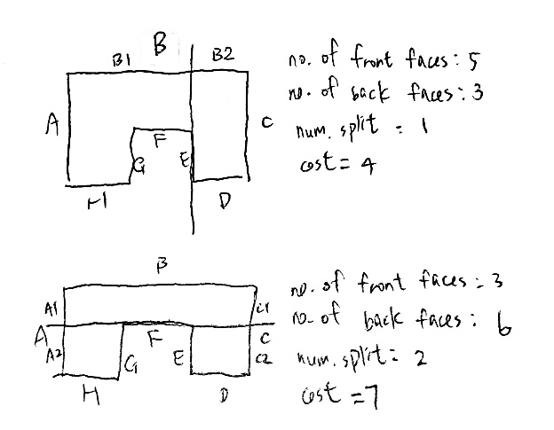

By symmetry, selecting plane G is the same as selecting plane E. We simply select the E hyperplane.

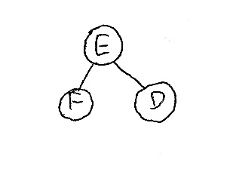

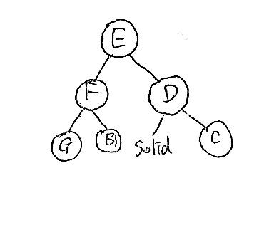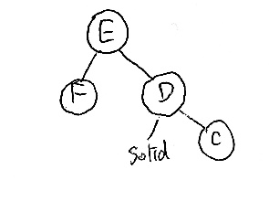

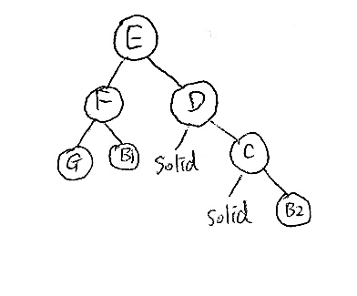

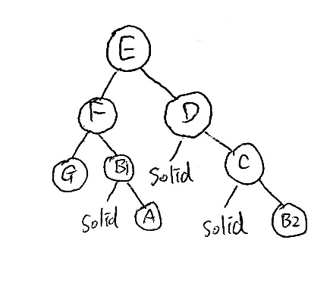

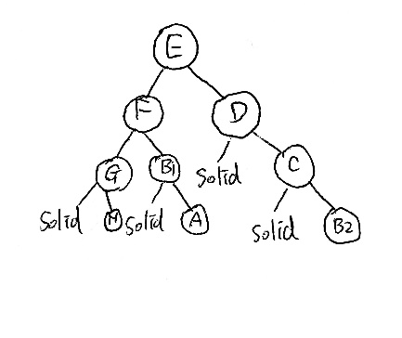

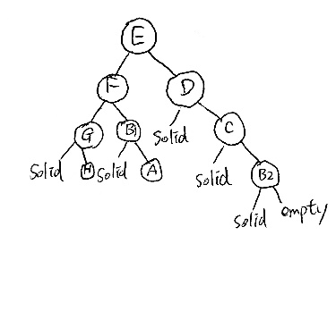

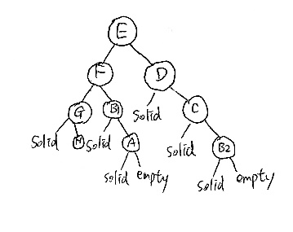

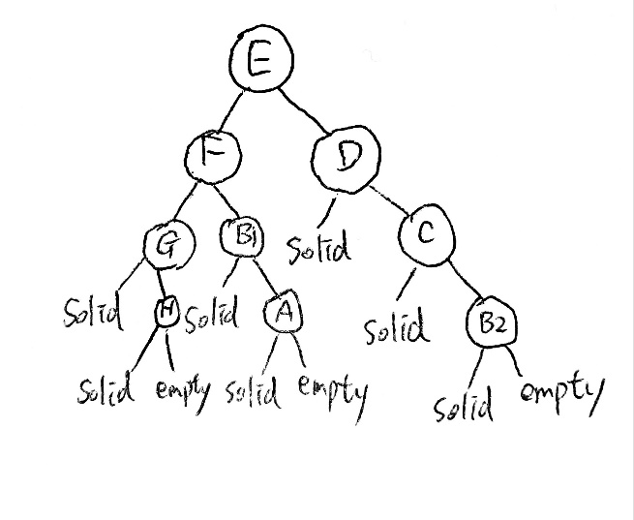

Q2

The feature of Lumen includes Color Bleeding, Soft Indirect Shadow, Multi-bounce Indirect Illumination, Emissive Surface, SkyLight Emissive

Color Bleeding describes the way the color of an illuminated surface influences the surface around it. If we have a bright object and we let the light shining on it. The surface of that object will be colored by the light to simulate the light reflection of the object.

Soft Indirect Shadow help object ground in parts of the scene that are not directly lit. Every object will create an effect that the ground near the object will become dimmer to simulate the shadow effect.

Multi-bounce Indirect Illumination calculates the current frame by tracing against the previous frame’s lighting. This creates a perfect lighting effect when we turn on some light sources.

The emissive property of materials injects indirect lighting into the scene in real time.

The SkyLight captures the distant parts of level and injects that to the scene as an indirect light. Then the sky’s appearance and its lighting and its reflection will match.

These are the important features the software engineers work on it.

Lumen will fail to calculate the lighting result if we use emissive surface to replace the light source. The emissive surface should be large and not too bright. Small and brighter meshes will add lots of noise to the scene. For example, we should not use the emissive surface for the streetlight because it is a small and bright mesh.

b)

Nanite is the UE5 virtualized geometry system. The geometry complexity of Nanite mesh increases multiple orders of magnitude comparing to the static mesh. Also, we can directly import film-quality source arts in Nanite, Moreover, Nanite use high poly detailing rather than baking detail into normal map textures. These are general features of Nanite.

i)

In Nanite, if artists would like to use high resolution polycount models, Nanite will analyzed the model and break it down into hierarchical clusters of triangle group. Then, during rendering, these hierarchical clusters are swapped on the fly at varying levels of detail based on the camera view. These hierarchical clusters are then connected to neighboring clusters within the same object. Thus, artists can freely use any high resolution polycount models. Nanite supports him to do so.

ii)

For geometry, Nanite meshes do not currently support custom depth or stencil, and vertex painting on instances.

For material, Nanite supports materials which have their blend mode set to Opaque. Other material types are disallowed or will have no effect on Nanite meshes when used.

For rendering, there are many rendering features not supported. These features include view-specific filtering of objects using minimum screen radius and distance culling, Forward Rendering, Stereo rendering, Split Screed, Multisampling Anti-Aliasing, Lighting Channels and Raytracing against the fully detailed Nanite mesh.

For supported platforms, Nanite is currently supported on PS5, Xbox Series S | X, and PCs with graphic cards meeting the specifications.

Q3

a)

The remade one has improved the user immersiveness. Originally, players can clearly see the entire game world. So, it is not easy to scare players. However, when the game has been remade and change the camera view to over-the-shoulder view. Player can just see the game world in front of the character. As a result, the game can scare players by attacking the player from its back. The player can have more immerse feeling and be more excited.

b)

The old one should use deferred rendering while the remade one should use forward rendering.

Deferred rendering separates geometry and lighting calculations. The lighting calculation is in screen space. It reduces the complexity of lighting calculation. The shortcomings of deferred rendering are it needs big memory for G-buffers, it does not support anti-aliasing, it is difficult to handle transparency and only one material can be used. As in the screenshot in the old Resident Evil 3, we can see a lot of aliasing on the character body.

The remade one uses forward rendering. Forward rendering is the modern techniques. Primitives are packed together and send as a batch. The possible shortcoming is that it is not suitable for dynamic geometry.

c)

The lighting effect and texture mapping improve a lot for the remade one.

As in the screenshot in the old Resident Evil 3, we can see that there are rounded black circle under the characters’ leg which is used to simulate the shadow of the characters. It does not consider the direction of the light. However, for the remade one, there are light shining from the shop. We can see a gradient brightness on the ground. The light fades out.

The texture in the remade one looks more realistic. Comparing the floor of the screenshots, the remade one contains more surface detail while the old one is just a shining surface.